North Georgia Clergy Spouses’ Retreat
March 10-12, 2017

“All Peoples…..All Nations”
Isaiah 25: 6-10

Lake Junaluska Conference & Retreat Center
Terrace Hotel
Lake Junaluska, NC

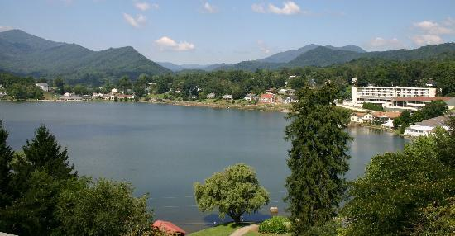

Speaker – Marjorie Kimbrough

Music Leader – Heather Petero

Come rest and rejuvenate
through spoken word and music!

Retreat Details:
- Check-in time on Friday, March 10th - 4:00 p.m.
- Check-out time on Sunday, March 12th - 11: 00 a.m.
- Meals included: Friday dinner, Saturday breakfast & dinner, and Sunday breakfast
- Free time activities on Saturday
  - Biltmore Estate: $48.00
  - Nearby shopping
  - Lake Junaluska activities
- You can request a single, double, triple, or quad room.
  - If you have a specific roommate request, please note on registration form

Registration deadline is February 1st

2016 Clergy Spouse Retreat Registration Form
NOTE: All registrations must be received by February 1st.

Full Name __________________________________________________________________________________________________

District _____________________________________________________________________________________________________

Church _____________________________________________________________________________________________________

Active_____ Retired_____ Widow_____

Street Address or PO Box ______________________________________________________________________________________

City, State, & Zip Code ________________________________________________________________________________________

Cell Phone (____) __________________ Home Phone (____) ____________________

Email Address _______________________________________________________________________________________________

Emergency Contact (name and phone) __________________________________________________________________________

_____Yes, I have a special need (dietary, wheel chair, etc.). Please provide specifics of your need _________________________

___________________________________________________________________________________________________________

Is this your first retreat? Please circle YES or NO.

Need help with the cost? Scholarship funds are available through the Mildred Smith Fund. For scholarship information, please check here.
_____Yes, please contact me about scholarship funds availability.

Roommate preference(s):_______________________________________________________________________ If no preferences are listed, we will assign roommate(s). We will do our best to fill the rooms as requested. If it is not possible, or if one of your designated roommates withdraws, then there may be an additional charge.

*The Mildred Smith Scholarship Fund provides funds for spouses to attend the retreat who might not otherwise be able to attend. Please consider a donation below to this worthy fund.
Donation Amount: ________________

Full-time attendance includes:

- Room for two nights
- Meals - Friday dinner, Saturday breakfast and dinner, and Sunday breakfast
- Lunch Saturday will be on your own depending on free time plans
- Retreat expense (meeting room, sound system, etc.)

Regular Room
___Single room $305
___Double $205
___Triple $172
___Quadruple $130

Make checks payable to No. GA Clergy Spouse Retreat
Mail checks and completed form to Diane Alred 4821 Sherry Ln. Acworth, GA 30101 by February 1, 2017

