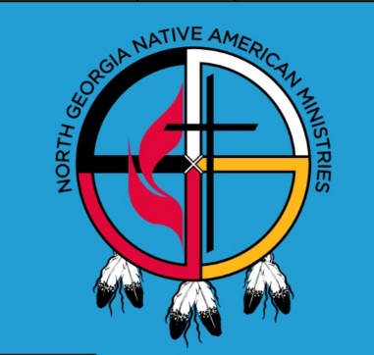
Committee on Native American Ministries
The North Georgia Conference of The United Methodist Church
invites you to the 10th anniversary
Native American Spring Gathering
Pine Log United Methodist Campground
3497 Pine Log Road - Rydal, GA 30171
Saturday, May 4, 2024 - Arrive by 10:30 AM
For more info call 678-227-3004 or email pastor.becki@comcast.net .

(Please complete a separate form for people living at a different address.)
REGISTRATION FORM Due April 14, 2024 (email to pastor.becki@comcast.net)
For late reservations or to register by phone call Dr. Jones at 678-227-3004

NAME: FIRST_____________________MIDDLE________________LAST___________________________
NAME YOU PREFER ON NAMETAG_________________________________________________________
STREET ADDRESS____________________________________________PO BOX______________________
CITY____________________________STATE_____________ZIP____________PHONE_________________
EMAIL_____________________________________________CHURCH_________________________________
TRIBAL HERITAGE OR ETHNICTY__________________________________________________________
AGE - CIRCLE ONE: 60+ y 18-59 y 12-17 y 6-11 y 2-5 y Inf - 23 mon
T-SHIRT SIZE – CIRCLE ONE 4XL 3XL 2XL XL LG MED SM
ADDITIONAL HOUSEHOLD MEMBERS ATTENDING WITH YOU
NAME: FIRST________________________MIDDLE_____________LAST___________________________
NAME YOU PREFER ON NAMETAG_________________________________________________
TRIBAL HERITAGE OR ETHNICTY_________________________________________________________
AGE - CIRCLE ONE: 60+ y 18-59 y 12-17 y 6-11 y 2-5 y Inf - 23 mon
T-SHIRT SIZE – CIRCLE ONE 4XL 3XL 2XL XL LG MED SM
(Additional Household Registrations on reverse)

page 2 – begin on page 1
10th anniversary celebration of our Gathering Ministry
For late reservations or to register by phone
call Dr. Jones at 678-227-3004
Complete a separate form for those with different addresses.

NAME: FIRST________________________MIDDLE____________LAST____________________________
NAME YOU PREFER ON NAMETAG_________________________________________________
TRIBAL HERITAGE OR ETHNICTY__________________________________________________________
AGE - CIRCLE ONE: 60+ yr 18-59 yr 12-17 yr 6-11 yr 2-5 yr Inf - 23 mon
T-SHIRT SIZE – CIRCLE ONE 4XL 3XL 2XL XL LG MED SM

NAME: FIRST________________________MIDDLE____________LAST____________________________
NAME YOU PREFER ON NAMETAG_________________________________________________________
TRIBAL HERITAGE OR ETHNICTY__________________________________________________________
AGE - CIRCLE ONE: 60+ yr 18-59 yr 12-17 yr 6-11 yr 2-5 yr Inf - 23 mon
T-SHIRT SIZE – CIRCLE ONE 4XL 3XL 2XL XL LG MED SM

NAME: FIRST________________________MIDDLE____________LAST____________________________
NAME YOU PREFER ON NAMETAG_________________________________________________________
TRIBAL HERITAGE OR ETHNICTY__________________________________________________________
AGE - CIRCLE ONE: 60+ yr 18-59 yr 12-17 yr 6-11 yr 2-5 yr Inf - 23 mon
T-SHIRT SIZE – CIRCLE ONE 4XL 3XL 2XL XL LG MED SM

